217.75 = 11011001.11

-14.125 = -1110.001

**Binary**: 11011.0011

Normalized representation: 1.10110011 x 10100

Mantissa: 1.10110011

Exponent: 100

Sign bit: 0

Adjusted exponent: 1000 0011 (127+exp)

Adjusted mantissa: 1011 0011 0000 0000 0000 000

**0 1000 0011 1011 0011 0000 0000 0000 000**

Zero – All 0’s in exponent, All 0’s in fraction

Infinity – All 1’s in exponent, All 0’s in fraction

NaN – All 1’s in exponent, All non-zero in fraction

A = AB

**Cartesian representation** a = (a1, a2)

**Magnitude** ||a|| = sqrt(a12 + a22)

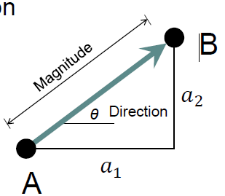

Sin, cos, tan(theta)

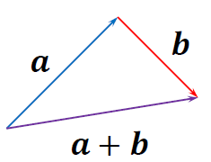

(a + b) = (a1 + b1, a2 + b2)

(a - b) = (a1 - b1, a2 - b2)

**Dot product**

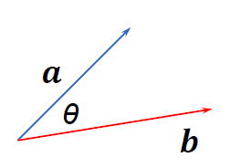a∙b = ||a||||b||cos(𝜃) => a∙b = a1b1 + a2b2

**Cross Product**

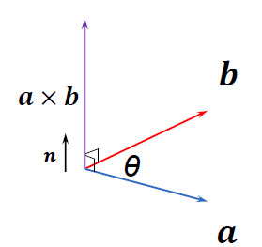 axb = ||a||||b||sin(𝜃)**n** => axb = a1b2 - a2b1

a x b = -b x a

**Determinants**

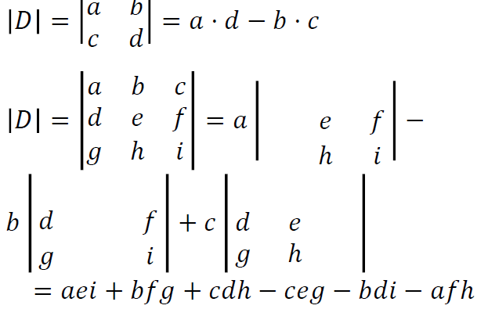

**Line Segment**

Length = ||a - b||

**CCW**

**Collinear**(p1, p2, ptarget)

Return p1p2 x p1p == 0

**Direction**(p1, p2, ptarget)

If p1p2 x p1p < 0 return Right

If p1p2 x p1p > 0 return Left

= 0 return On the line, collinear

**Point-Line Relate**

**Line-Line Relate**

**Intersect?**(p1, p2, p3, p4)

If p1p2 x p3p4 != 0, return true

Also If collinear, return true

**Convex Hull**

**Graham Scan**

Choose base point with the Minimum y

Sort points in CCW order {p0, p1, p2…}

**Monotone Chain**

Sort by x-val

**Gift Wrapping**

**Divide & Conquer Convex Hull**